Boats on the Slip—L’Atalante
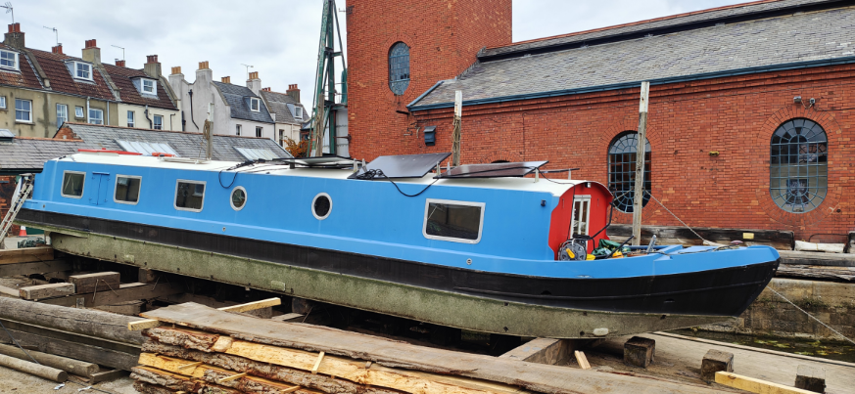
L’Atalante is arriving on the Underfall Yard slip on Friday 2 October. She is named after the 1934 French film about a newlywed couple struggling to adjust to early married life living on a canal boat.
She was built by Collingwood in 2012. Collingwood, based in Liverpool, are the largest company building canal boats in the UK.
She was originally built to be lived on, and remains so today, and will continue to do so hopefully for many more years. She has been in Bristol for the last five years, and is usually moored at Poole’s Wharf, Bristol Marina. Previously she was in Hemel Hempstead.
L’Atalante will be on the Underfall slip for blacking the hull.
Harry, her owner, will be carrying out the work himself.

Basic boat facts
Length, beam: 60ft x 12ft widebeam
Weight: Unknown
Construction materials: Steel hull
Engine type and power: Canaline 52bhp.

