Boats on the slip “ Valda”
Valda is an example of a class of boats known as Polperro Gaffers. She was probably built in Looe in the early 1900s and converted to a yacht in 1950. She’d been through a series of restorations before being bought by her current owner, boatbuilder Marcus Jennings, in 2016. Over the next seven years while working as a boatbuilder at Underfall Yard Marcus used his spare time and holidays to make repairs and improvements. These included new planks , recalking, replacing the bulwarks, decking, replacing ten sawn oak frames and stanchions and rebuilding her mast in preparation for sailing again. In 2023, after a wait of ten years he was about to start his own boat building business taking a lease on one of the Yard’s sheds when the fire occurred causing so much serious damage to the Yard and to the “Valda”. Time in the water since the fire caused further deterioration which now needs urgent action and is the reason for her being on the slip. Despite these setbacks Marcus hopes to restore her for a second time and eventually get her back sailing again perhaps being ready for joining the “ Polperro Gaffer Regatta” in 2028.
Polperro Gaffers
For more detail about “Polperro Gaffers” follow this link: Polperro Gaffers .
Source: https://grokipedia.com/page/polperro_gaffer
Photo source:
https://oga.org.uk/_documents/%5B963455%5DThe_Dog_Watch_Edition_55_March_2024.pdf
Other Valda images from Marcus Jennings
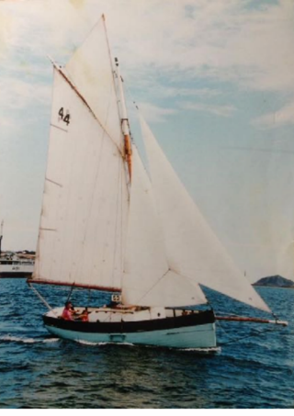
Figure 1: The "Valda" at sea

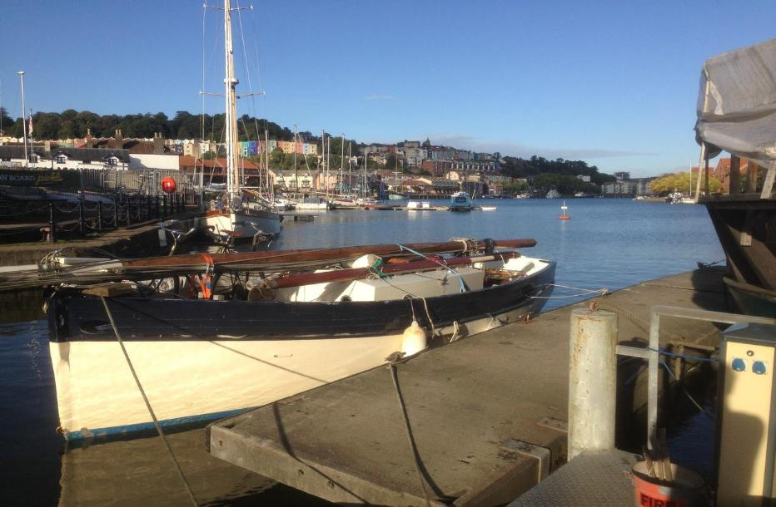
Figure 2: The “ Valda” on arrival at Underfall Yard in 2016

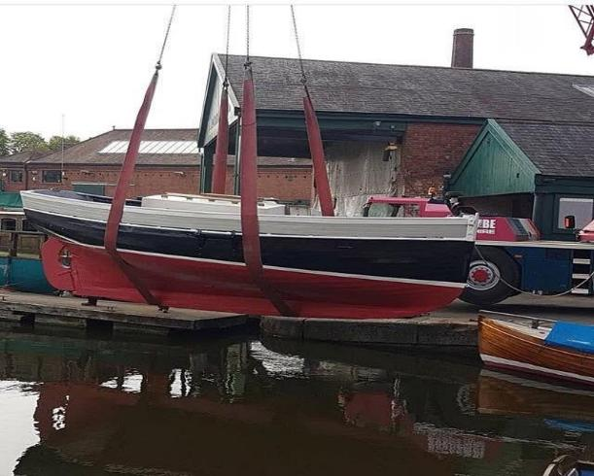
Figure 3: The Valda back being put back in the water in 2023

