Boats on the Slip
The Fairy Rae
Built as a cargo vessel by Dutch firm Zealander in 1931, the Fairy Rae was originally just a cobalt steel hull and wheel house used for transporting concrete during the 30’s and the second world war.
She had a series of owners, one of whom reportedly won her in card game, before being brought to the UK in 2010 and converted to the current design.
The current owners, Flo & Joshua Camacho-Clowes turned her into a houseboat/home for themselves and their 3 Golden Retrievers with accommodation comprising one bedroom, bathroom with shower, living space with woodburner and kitchen with full appliances and modern features. The wheel house acts a lounge area and dining area in the warmer months. She’s spent the last 2 two winters in Bristol’s floating harbour and the summers exploring the Kennet & Avon.
While on the slipway the owners will be applying fresh coat of bitumen to the hull then back on the water with her new name “Bon Barge” which acknowledges Flo & Josh’s fashion brand “Bon Clothing” which can be found in Bristol’s St Nicks market.
Boat Facts
Length 47ft
Air draft: 8ft
Water draft: 2ft 8ins
Beam: 7ft 3 ins
Wheel steering (pulley system)
Engine : Ebro old tractor engine !
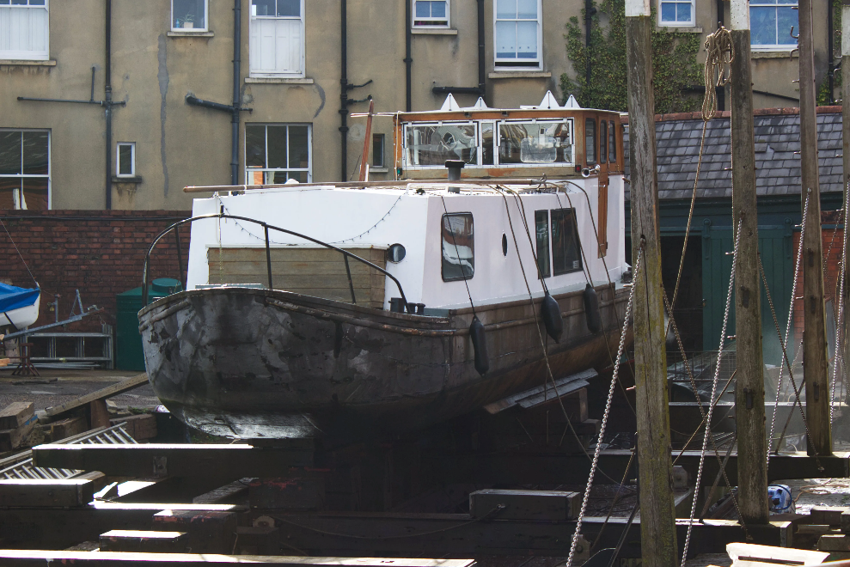
Registration: Canal and River Craft ( CRT) Licence 592222 which will chang to take account of the new name.

